**Lab 14 – Routing with Packet Tracer**

**Objective**: Understand the concepts of

Masks

Routing

1. Using Cisco Packet Tracer, build the network of Figure 1.

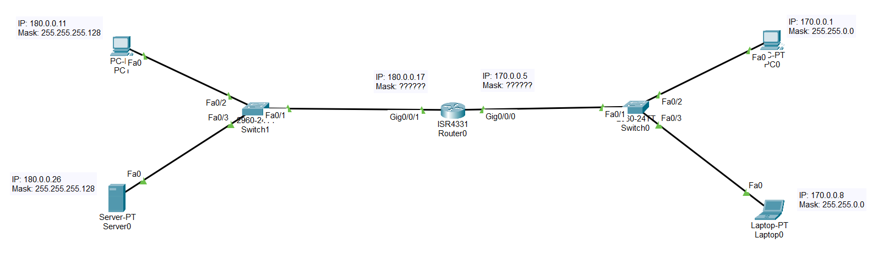

Figure 1

1. As we did in Lab 12 (with GNS3), configure all the devices so that there is full connectivity between all four devices (i.e., you should be able to ping from any device to any device). Please add all the annotations as indicated in Figure 1.
2. On the PC0, use the command mkdir to **create a directory named <your_last_name>**
3. On PC0, use the command **cd** to enter the directory you just created.
4. Show a screen capture where you successfully ping from PC0 to Server0. Your screen capture should look like this one:

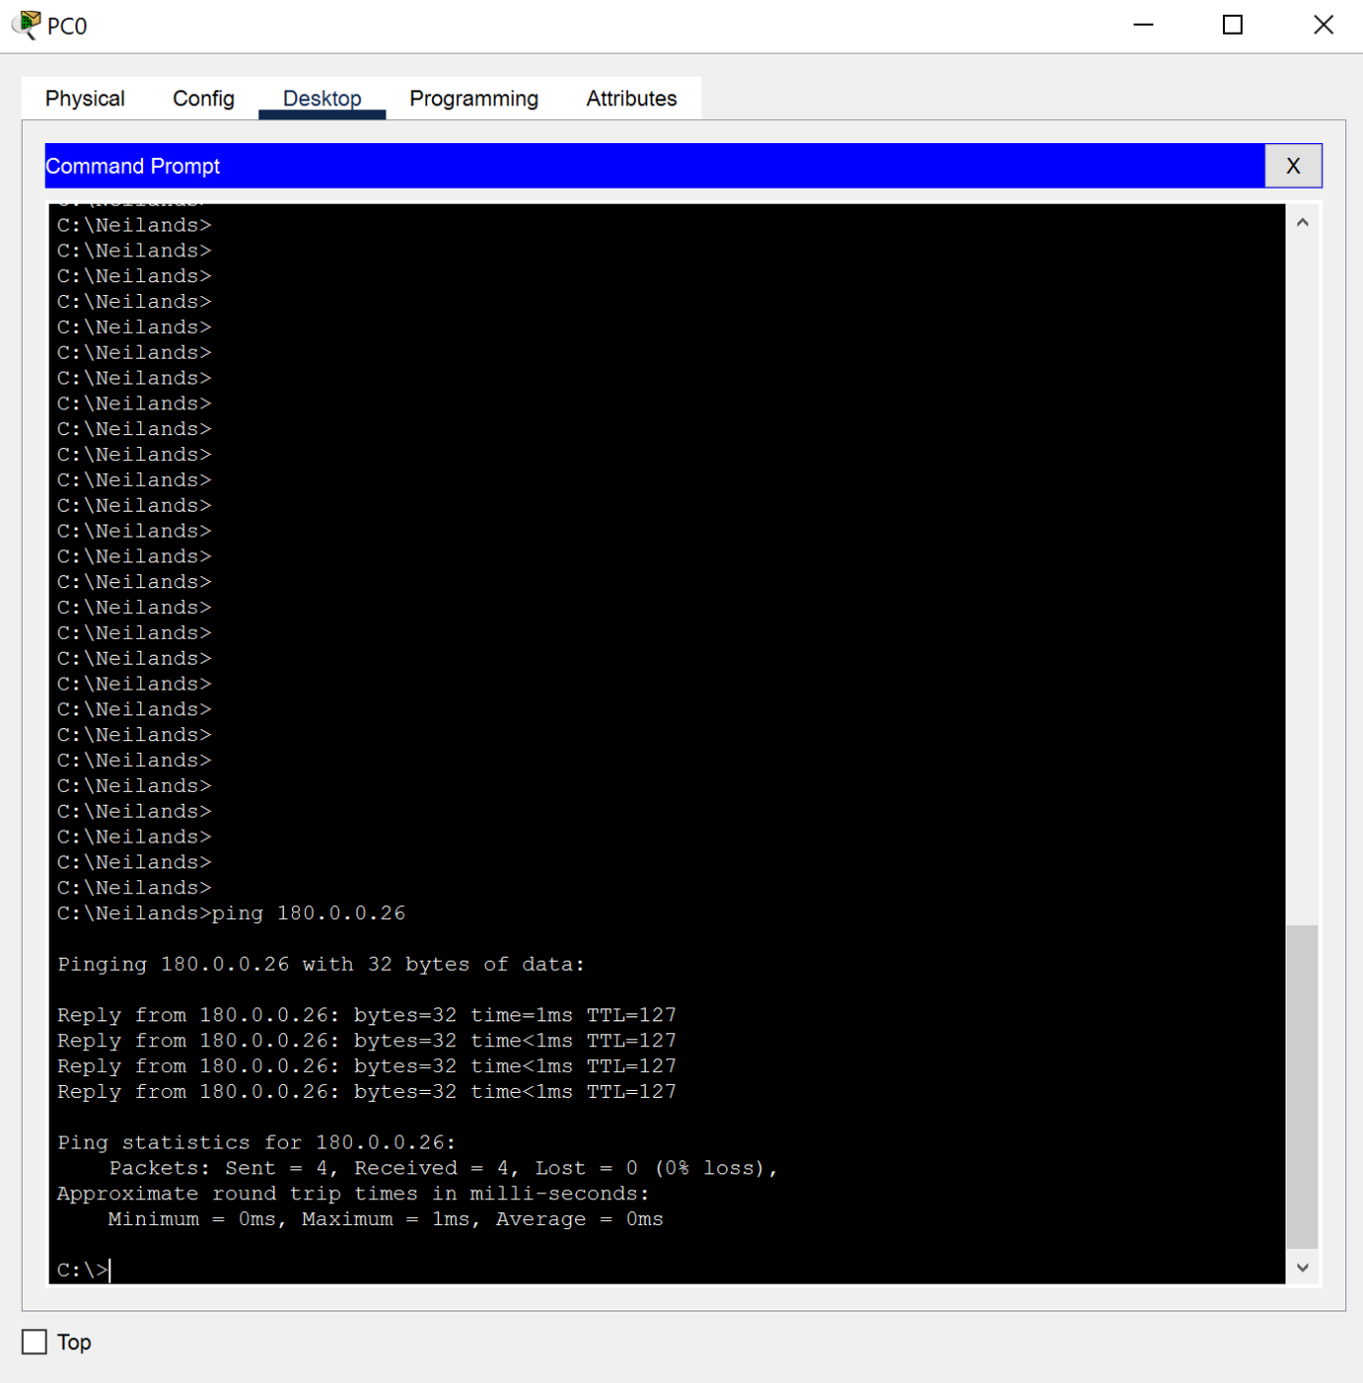

1. On Laptop0, use the command mkdir to **create a directory named <your_last_name>**
2. On Laptop0, use the command **cd** to enter the directory you just created.
3. Show a screen capture where you successfully ping from Laptop0 to PC1. Your screen capture should look like this one:

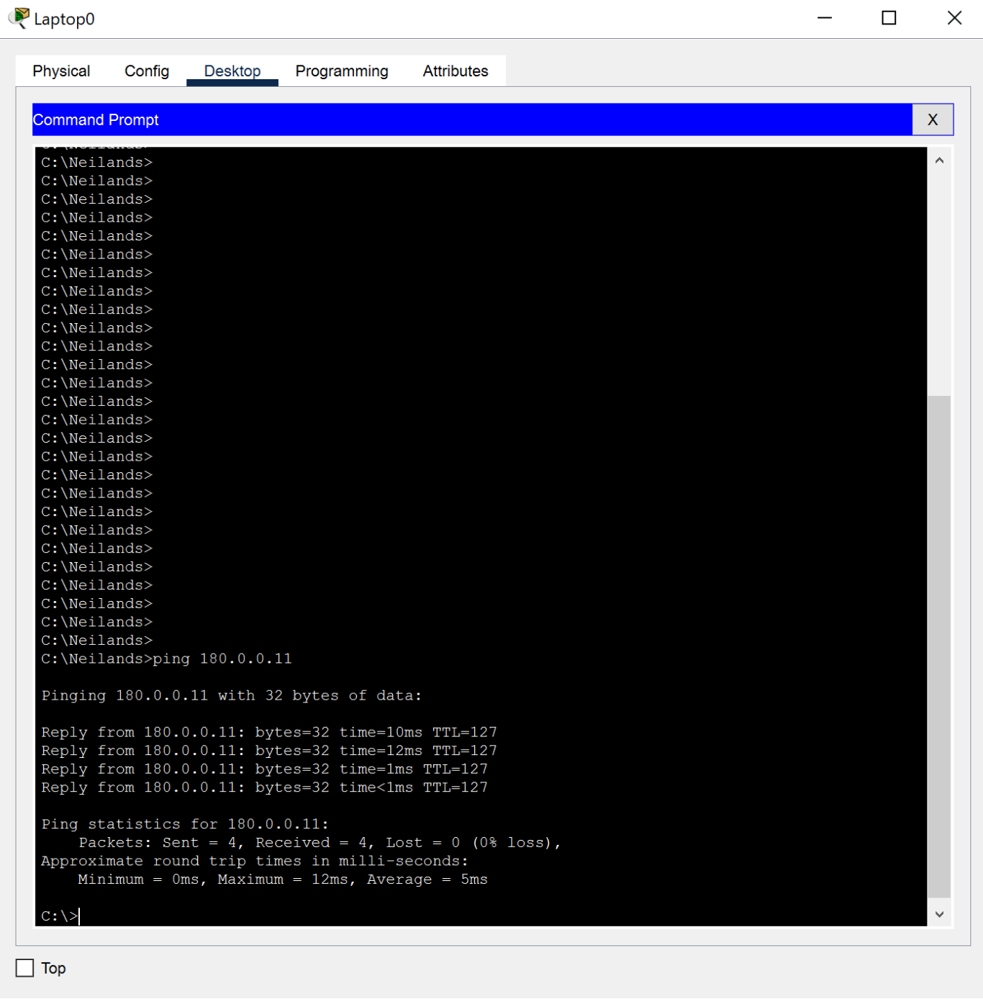

**Submission:**

Submit

* Your Packet tracer project
* This Word file AFTER replacing my screen captures with **your screen captures**.